PRAYER INTENTIONS FOR 16 DAYS OF ACTION TO END VIOLENCE AGAINST WOMEN AND GIRLS
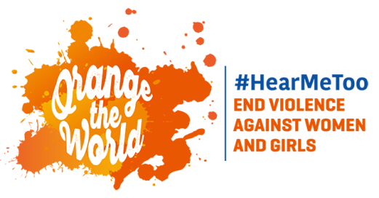
November 25 is the UN Day for the Elimination of Violence Against Women (and Girls). It is the beginning of 16 days of action to end such violence, leading up to December 10, which is the 70th Anniversary of the Universal Declaration of Human Rights. We invite you to:
- Offer a prayer intention (see below) each day as the world unites to stop violence
- Wear orange November 25 to December 10 as a symbol of a bright, violence-free future
SUNDAY | MONDAY | TUESDAY | WEDNESDAY | THURSDAY | FRIDAY | SATURDAY
Nov. 25  For women and children who suffer from, or are survivors of, domestic violence | Nov. 26  For an end to bullying of girls in school, including cyber bullying | Nov. 27  For courage for women who suffer injustice—forced labor, inadequate wages, or harassment in their workplaces | Nov. 28  For protection of girls from forced child marriage and female genital mutilation | Nov. 29  For women and girls who are trafficked and sexually exploited. | Nov. 30  That women and girls who experience violence may have the courage to report it, and be supported, rather than shamed or judged in the process | Dec. 1  For an end to honor killings and other forms of femicide
Dec. 2  That boys and men may learn to treat girls and women with dignity and respect | Dec. 3  That society may be more proactive in protecting girls and women from kidnapping | Dec. 4  For end to the physical, sexual, emotional, and financial abuse of migrant women and girls | Dec. 5  That elderly women may experience tenderness, respect, and love | Dec. 6  That safety structures, such as police and courts, may respond with compassion to women and girls who experience violence | Dec. 7  For an end to all forms of rape.  For all women and girls who suffer war or conflict-related violence. | Dec. 8  That verbal, emotional, and financial abuse may be eliminated and that relationships may be mutually uplifting
Dec. 9  For the elimination of all forms of violence against women and girls with disabilities | Dec. 10  That human rights of women and girls may be protected, promoted.

